MazeBot Assembly Instructions - English

Follow pdf instructions (steps 1 – 7)
Step 7:
Instead of using the special split cables, use breadboard (pins are vertically connected).
The breadboard wiring should look something like as shown below:

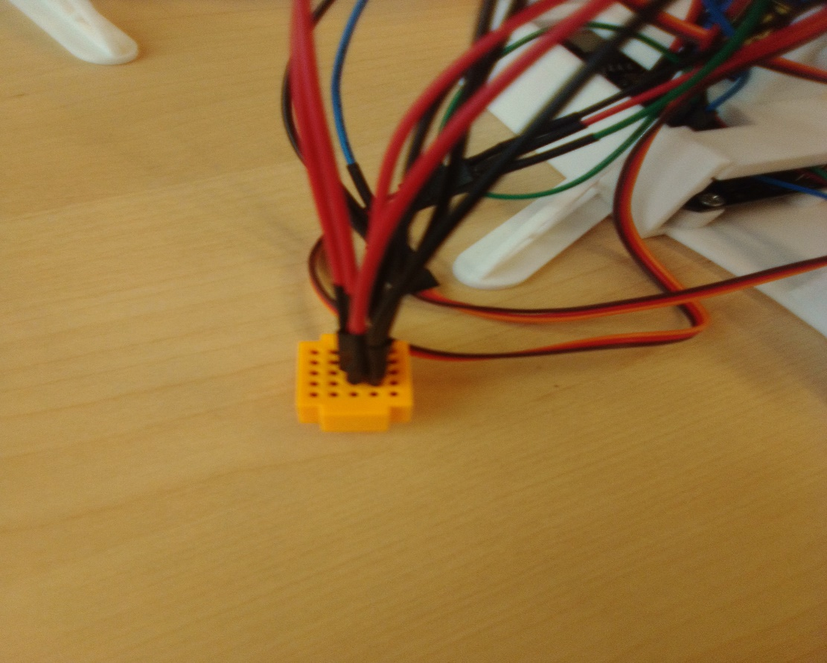

Mount breadboard on holes in front of joystick mount.

Continue assembly based on steps 14 – 29.

Make sure to test everything frequently.
Ensure that when mounting the maze itself that you screw the screws in well (they shouldn’t be any higher than the surrounding surface as they will block the ball from getting past)

Use the latest Arduino ide version when writing the code.

